Session 4 – Fun with variables

The only type of block we have not tried out yet is variables. Variables are a way to store information for sprites to use, keep track of game status, or other calculations.

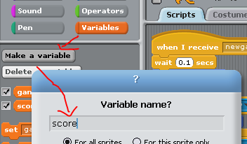**Step 1: Add a variable to your game**

Start up your game from week 2. If you don’t have the game, you can download it from the scratch website (user feesclub). Select Scratchie, then select the “Variables” block (the orange one) and create two variables, ‘score’ and ‘gameover’:

**Step 2: Add variables to game**

Modify the game so that it starts on an event rather than the green flag. Set the score and gameover to 0 at the beginning of the game. What score is needed to end the game?

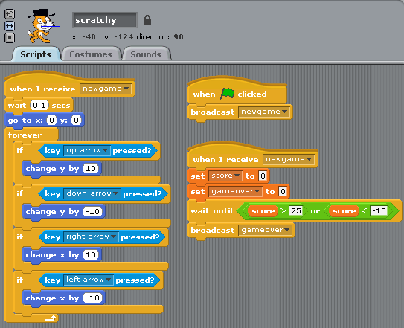

**Step 3: Modify the monsters**

Now change your monsters to use variables. How many points do you get when you catch the red monster?. Create another creature star that will chase Scratchie. Both will keep going until the variable “gameover” is set to ‘1’.

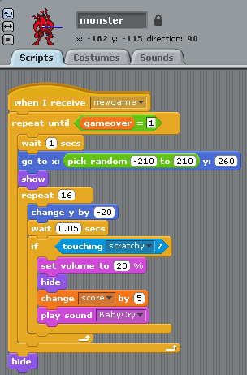 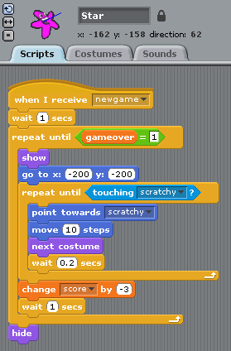

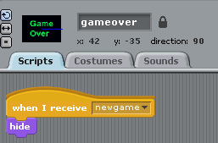**Step 4: Game over**

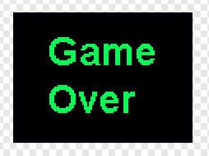Now we create a script that handles the end of the game. You can add this logic to the stage, Scratchie, or create a new sprite. I created a new one called ‘gameover’. The first thing that it does when a new game starts is hide itself.

The gameover sprite stops the rest of the sprites by setting ‘gameover’ to 1. You can also do this kind of thing with events. The sprite checks the score to see if you win or lose then asks if you want to play again.

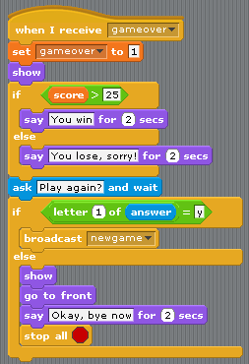

**More project ideas**

* A list is a variable that can have multiple values. Can you add your score to a list ‘highscores’?
* Make another sprite that chases Scratchie in a different way.
* Change the background for each new game
* Darken the background color when gameover = 1, raise it back when gameover = 0